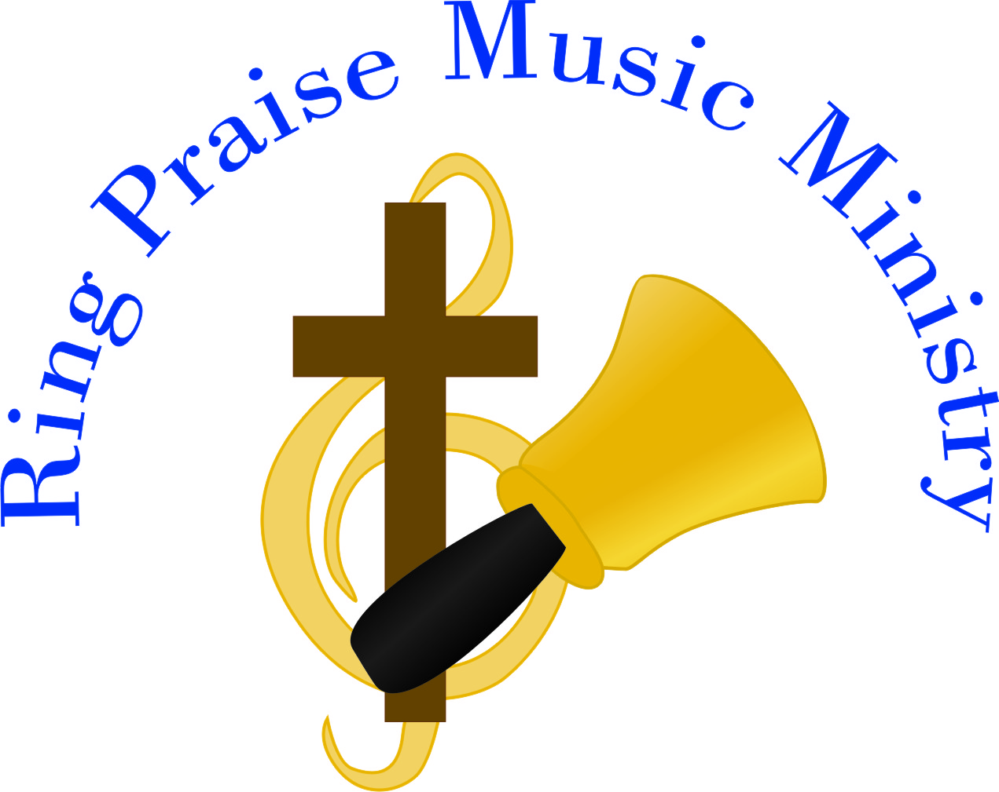
Press Release

The unique and beautiful blend of handbells and piano will resound at a Ring Praise concert on DAY & DATE at TIME at LOCATION & ADDRESS. Woven with hymn history and scripture, Phyllis Tincher, handbell soloist, and Sean Rogers, pianist and organist, will touch your hearts and ears with a variety of songs focusing on praising God.

Through contemporary praise songs, hymns and reflective pieces, they tell the saving story of Jesus Christ. In addition to accompanying, Sean will also play a few piano solos. Phyllis rings 3 octaves of handbells and mixes in 2 octaves of handchimes.

During the concert the audience will have an opportunity to ring handchimes as everyone sings. No music experience is needed – young and old enjoy this portion of their program.

An offering will be taken to support their ministry. For additional information, please visit their website, www.RingPraiseMinistry.org.

Tincher and Rogers have made four CDs together which will be available at the concert. Ring Praise, Ring Praise 2 and Ring Praise 3 are collections of hymn arrangements. Come to the Manger celebrates Christmas. The cost of each CD is $15 and all proceeds help fund Ring Praise Music Ministry.

Phyllis Tincher has been solo ringing since 1997 and has directed adult and youth handbell choirs since 1993. Currently she directs a women’s handbell group at her church, Crossroads Community Church, Nampa, Idaho. She has served as guest conductor at festivals and taught many classes at handbell conferences and workshops.

The Reverend Sean M. Rogers is an Episcopal Priest serving St. Matthew’s Episcopal Church and Grace Chapel at Snake River Correctional Institution in Ontario, Oregon. Sean is a concert pianist and organist and also works as a music coach and accompanist for opera singers and instrumentalists. Rogers holds four Bachelor Degrees from The College of Idaho in Religion, Sacred Music, Organ Performance and Piano Performance. Sean has three personal CDs which will be available at the concert and cost $15 each. I Will Be with Thee and Spirit are collections of original compositions and hymn arrangements. Moonlight Serenade is an assortment of popular tunes played on the theatre organ.

